Where Should I Start????
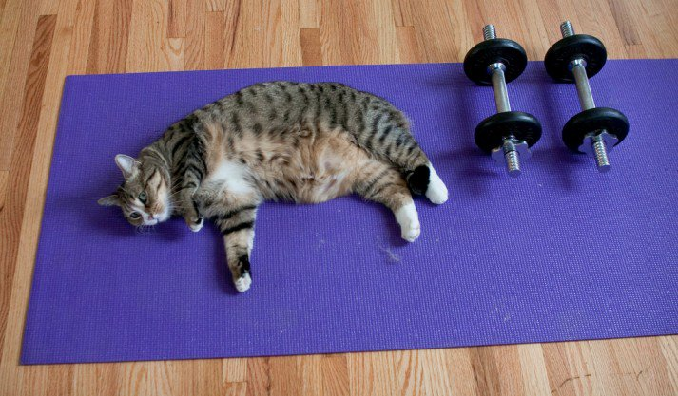
So you want to run track, and you have no idea how to start.
You probably feel like the cat in the image above, and you’re thinking to yourself, “dumbbells, push-ups, squats. These are terms I’ve HEARD before, but how do I combine them into a workout to get in shape? HELP.”
I got you.
Here’s a quick overview:
- Reps in the 1-5 range build super dense muscle and strength.
- Reps in the 6-12 range build a somewhat equal amounts of muscular strength and muscular endurance.
- Reps in the 12+ range build muscular endurance and size
Many beginner strength programs end up doing 5 sets of 5 reps each, in an effort to optimize progress as a beginner interested in strength gains.
With a circuit, you’re completing one set of each exercise in order and then repeat the process again. (This is what we need to be doing)
Complete this workout plan for at least 20 minutes a day for the next 2 weeks to get ready for track season.

First Week
- 10-20 body weight squats
- 5-10 push ups
- 10-20 walking lunges Each leg
- 10-20 sit-up
- 30-60 second plank
- 30-50 jumping Jacks
- Repeat for 3 rounds
Second Week

- 20-30 body weight squats
- 10-15 push ups
- 20-30 walking lunges Each leg
- 20-30 sit-up
- 60 second plank
- 50 jumping Jacks
- Repeat for 3 rounds

Never forget to stretch before and after. During exercise you should be drinking a full bottle of water and a full bottle of water after. Strength training will make you quicker, faster and stronger.
IF you are sore, and you should be sore, stretch frequently during the day, eat a banana in the morning and make sure you get plenty of rest.
I look forward to starting this season with you.

